MultiRoofs LoD 2.2 CityJSON Generator
User practical guide
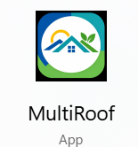

Prepared by:
- Razan Saadaldeen
- Alejandro Morales Hernández

Contents
1. Introduction 2
1.1 Requirements to Run the Tool 2
2.What is this tool used for? 3
3. Main parts of the interface 4
3.Before the first reconstruction 5
5. Generate a 3D building model 8
6. View the generated CityJSON model 10
7. Configuration File (.toml) 11
Summary 15

Introduction
- This document guides users through the complete workflow of the MultiRoofs user interface, from initial setup to generating and visualizing LoD 2.2 building models. Before using the interface for the first time, the user must download the appropriate Roofer executable for their operating system from the Roofer website; the relevant download link is provided in this document. The downloaded Roofer executable must then be selected through the File > Settings menu in the MultiRoofs user interface.
- For a standard reconstruction, three main inputs are required: the Roofer executable, LiDAR point-cloud data (.las or .laz), and building-footprint data (.gpkg). The user must also select an output folder to store the generated results. The document explains how to prepare and select these inputs, start the reconstruction process, monitor its progress, and visualize the resulting 3D CityJSON model. A separate section is dedicated to the configuration file (.toml), which provides an alternative way to define the Roofer settings and input/output paths.

1.1 Requirements to Run the Tool
Before using the MultiRoofs LoD 2.2 CityJSON Generator, the following components and input data are required:
- Roofer executable: Roofer must be available on the computer because it performs the actual LoD 2.2 building reconstruction. On first use, its executable path should be selected through the Settings window. This documentation provides instructions on where to download the appropriate Roofer executable and how to configure its path in the application through the Settings window.
- LiDAR point-cloud data: One or more .las or .laz files containing the point-cloud data required for the reconstruction.
- Building footprints: A .gpkg file containing the 2D building footprints corresponding to the area represented by the LiDAR data.
- Output location: A folder must be selected where the generated reconstruction results can be stored.
- Configuration file (optional): A prepared Roofer .toml configuration file can be selected when specific reconstruction settings are required. If no configuration file is needed, this field can be left empty. The Configuration File section of this documentation explains where to obtain the configuration file and how to prepare and use it with the MultiRoofs application. Selecting a configuration file is optional.
- Web browser (for visualization): A web browser is required when using View with CityJSON Ninja to visualize the generated 3D building model.
- The main generated output is a CityJSONSequence (.city.jsonl) file, which contains the reconstructed LoD 2.2 building model.

What is this tool used for?
The MultiRoofs user interface is the LoD 2.2 CityJSON Generator developed within the MultiRoofs project. It allows users to create 3D building models from LiDAR point-cloud data (.las or .laz) and 2D building footprints (.gpkg) using Roofer. It can be downloaded from here: Roofer.exe, to perform the reconstruction and store the generated building model as a CityJSONSequence output in a separate run folder.
After clicking the Roofer.exe link, you can download the appropriate version of Roofer.exe depending on the operating system running on your device. Figure 1 presents the official Roofer website and shows the available Roofer versions for the supported operating systems: Windows, Linux, and macOS.

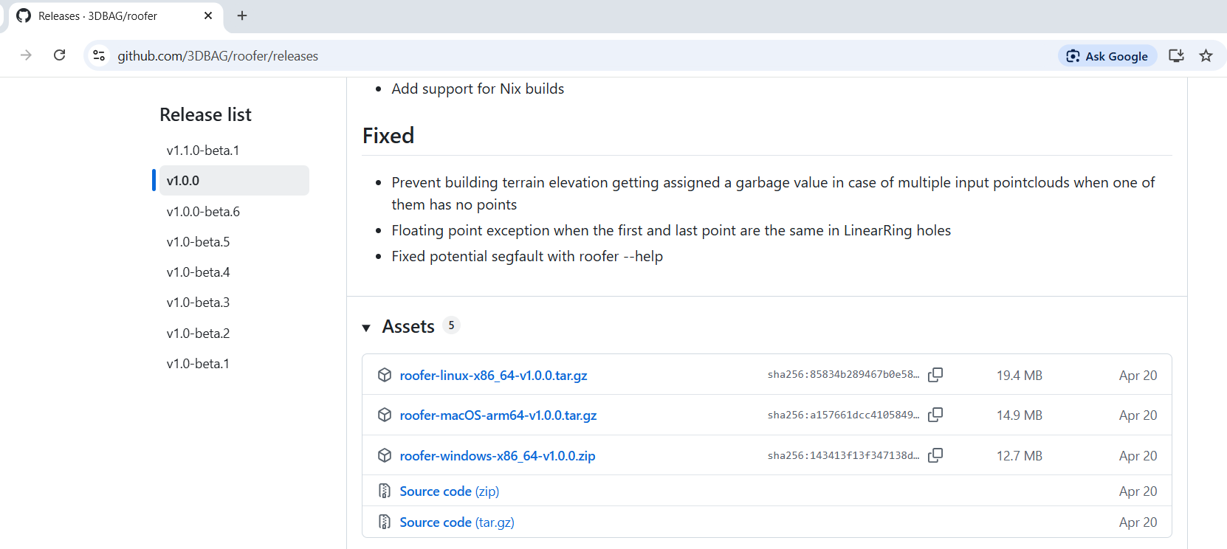

Figure 1. Roofer website and available versions for Windows, Linux, and macOS

Download and unzip the archive to access roofer.exe. Extract the contents of the ZIP archive and locate roofer.exe inside the bin/ directory (for Windows systems).
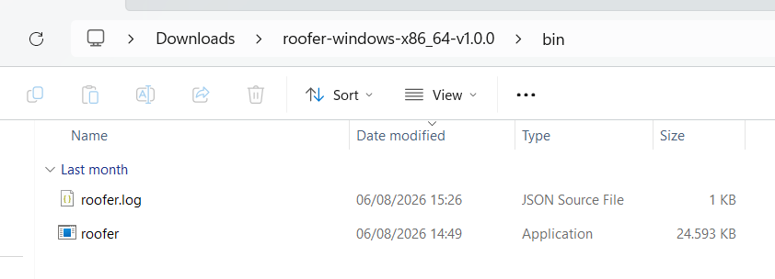
Figure 2. Downloading, extracting, and locating the executable program.
The following section describes the MultiRoof user interface after preparing roofer.exe. The interface shown in Figure 3 below is the MultiRoof user interface that lets users select the required input data, choose where to store results, start the reconstruction, follow the processing messages, and access the generated CityJSON files.
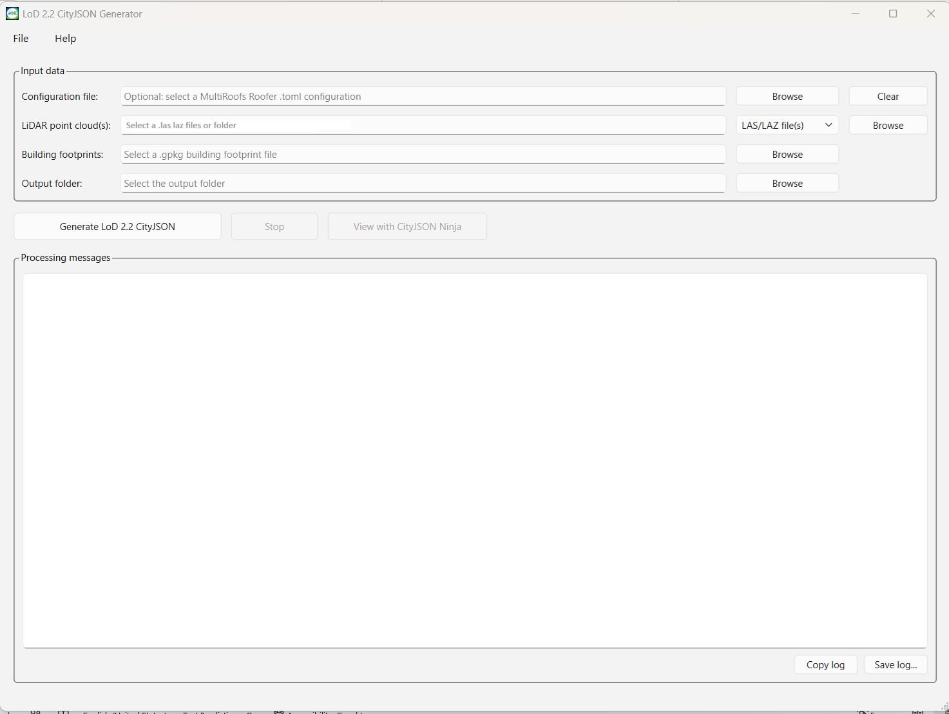
Figure 3: The user interface for MultiRoof

3. Main parts of the interface
The following are the important parts of the GUI that a user needs to understand.

# | GUI section | Purpose
1 | LiDAR point cloud  LiDAR folder | Select one or more .las or .laz point-cloud files.  Select a folder when the LiDAR input is stored as files in one folder. The folder must contain only .las or .laz files.
2 | Building footprints | Select the .gpkg file containing the 2D building footprints.
3 | Output folder | Select the main folder where the generated run folder and CityJSON results will be stored.
4 | Generate LOD 2.2 | Starts the LoD 2.2 building reconstruction.
5 | View CityJSON | Opens CityJSON Ninja and reveals the generated file so it can be uploaded/dragged into the viewer.
6 | Processing messages | Shows information and messages produced while Roofer is running. These messages are useful when checking whether a run completed successfully.
7 | Configuration file | Optional. Select a Roofer TOML configuration file when a prepared configuration should be used.
8 | File/ Settings | Lets the user select the Roofer executable used by the application.
9 | Help/ About | Shows information about the tool, the MultiRoofs project, development team, and project logos.

Before the first reconstruction
Before generating a model for the first time, from the user interface, open File, then select Settings and select the Roofer executable. The application remembers this location, so it normally does not need to be selected again unless Roofer is moved or replaced. Figure 4 illustrates the interface displayed after selecting the File > Settings option in the user interface.
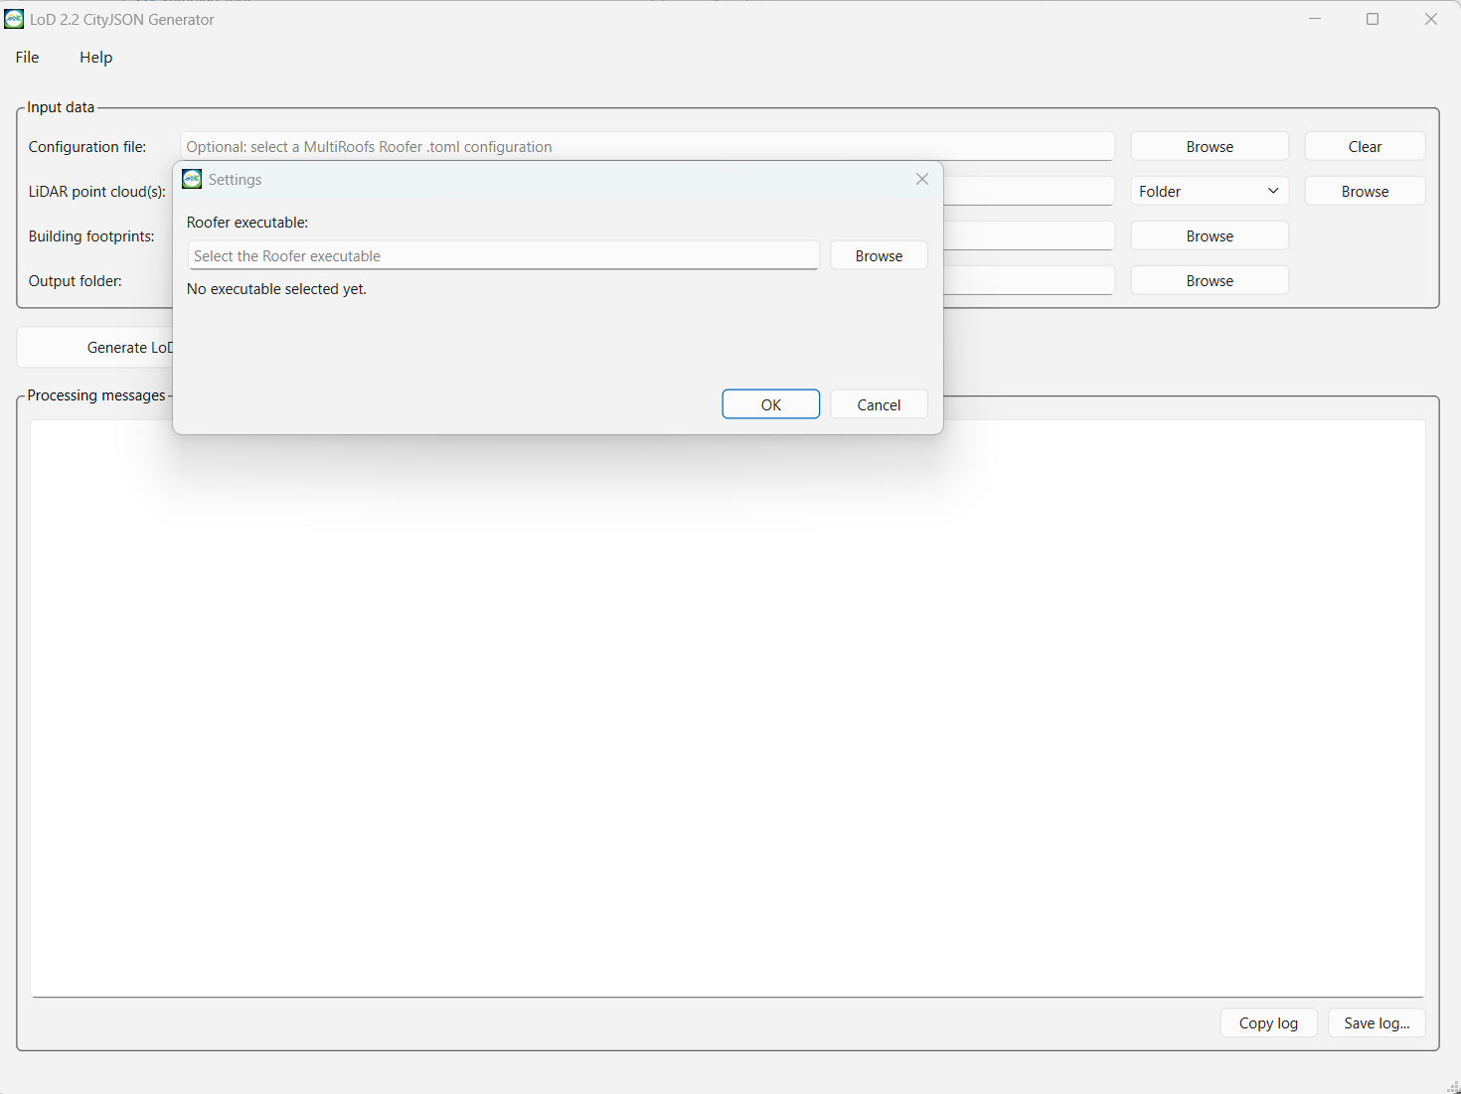
Figure 4: File > Settings allows you to select the path to the roofer.exe executable.
After clicking the Browse button, you can select the required file, as illustrated in Figure 5 below.
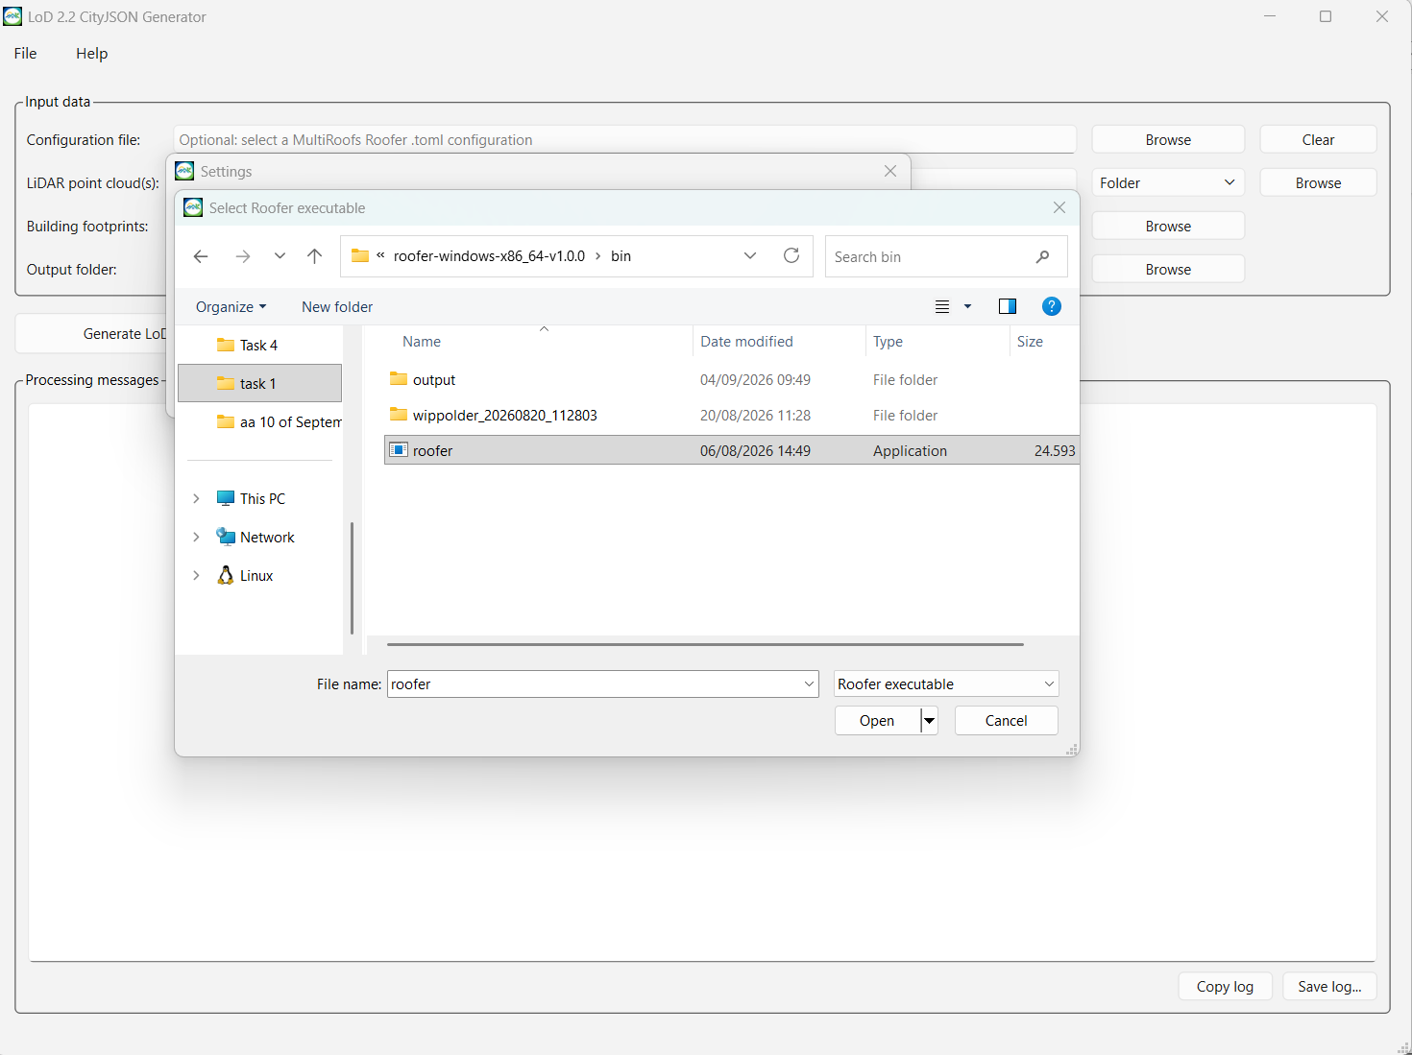
Figure 5: Selecting the roofer.exe file
If the target directory does not display roofer.exe, set the file filter to Executable Files (*.exe) or All Files to display all compatible files, including roofer.exe.
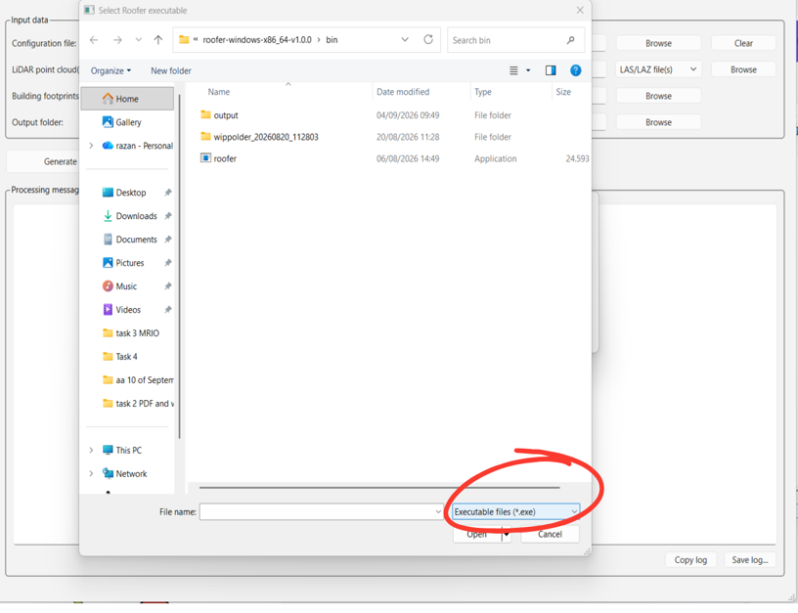
Figure 5. Configuring file filters to display executable files.
The path to roofer.exe requires initial configuration only, as the system interface retains this file path for subsequent sessions. application remembers this location, so it normally does not need to be selected again unless Roofer is moved or replaced.
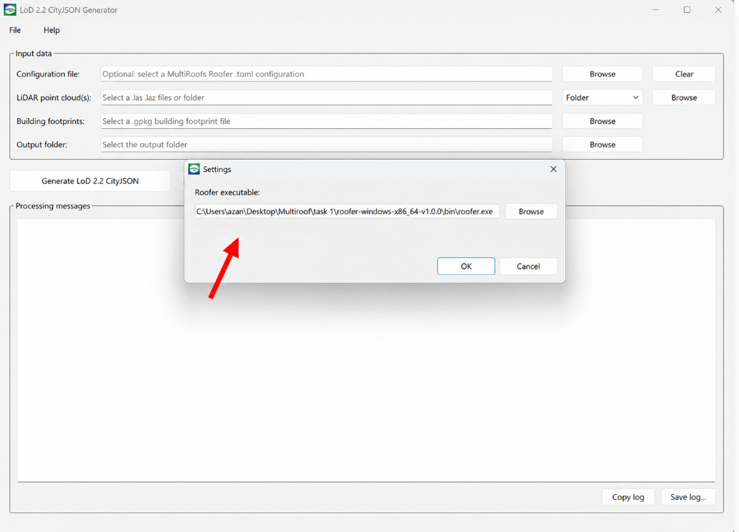
Figure 6. Executable path saved.

5. Generate a 3D building model
Currently, specifying a configuration file path is optional. The use and purpose of the configuration file are discussed later in this document under the section titled “Configuration File”; therefore, this section proceeds to the selection of the LAS file and the .gpkg file or directory.
Select the LiDAR input. Choose one or more .las/.laz files, or choose a folder containing the point-cloud files. Select the building footprints. Choose the required .gpkg building-footprint file.
Select the output folder. Choose the folder where the reconstruction results should be stored.

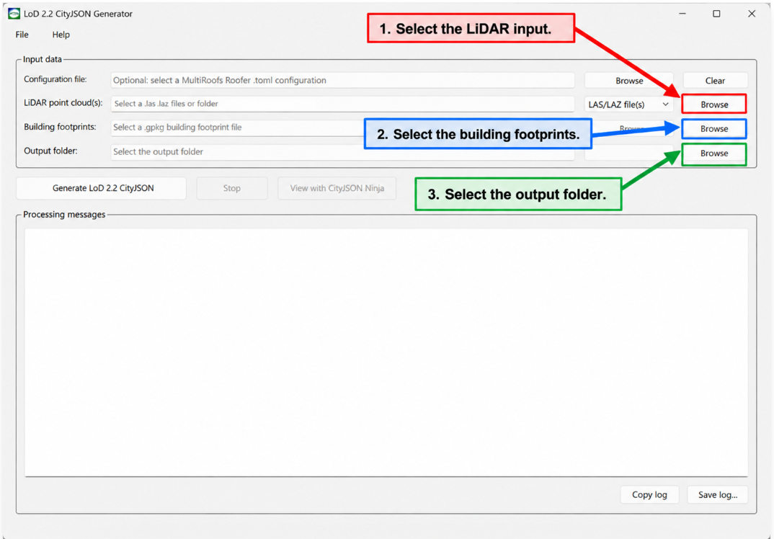
Figure 7. Selecting the input files and the output folder

Note that for the LAS input, you may select either an individual file/ files or a folder; however, the selected folder must contain only .las files.
After selecting the required input data and output folder, click Generate LoD 2.2 CityJSON to start the 3D building reconstruction process as shown in Figure 8 below. The progress and processing information are displayed in the Processing messages section. Once the reconstruction has been completed successfully, a confirmation message appears. Click OK.

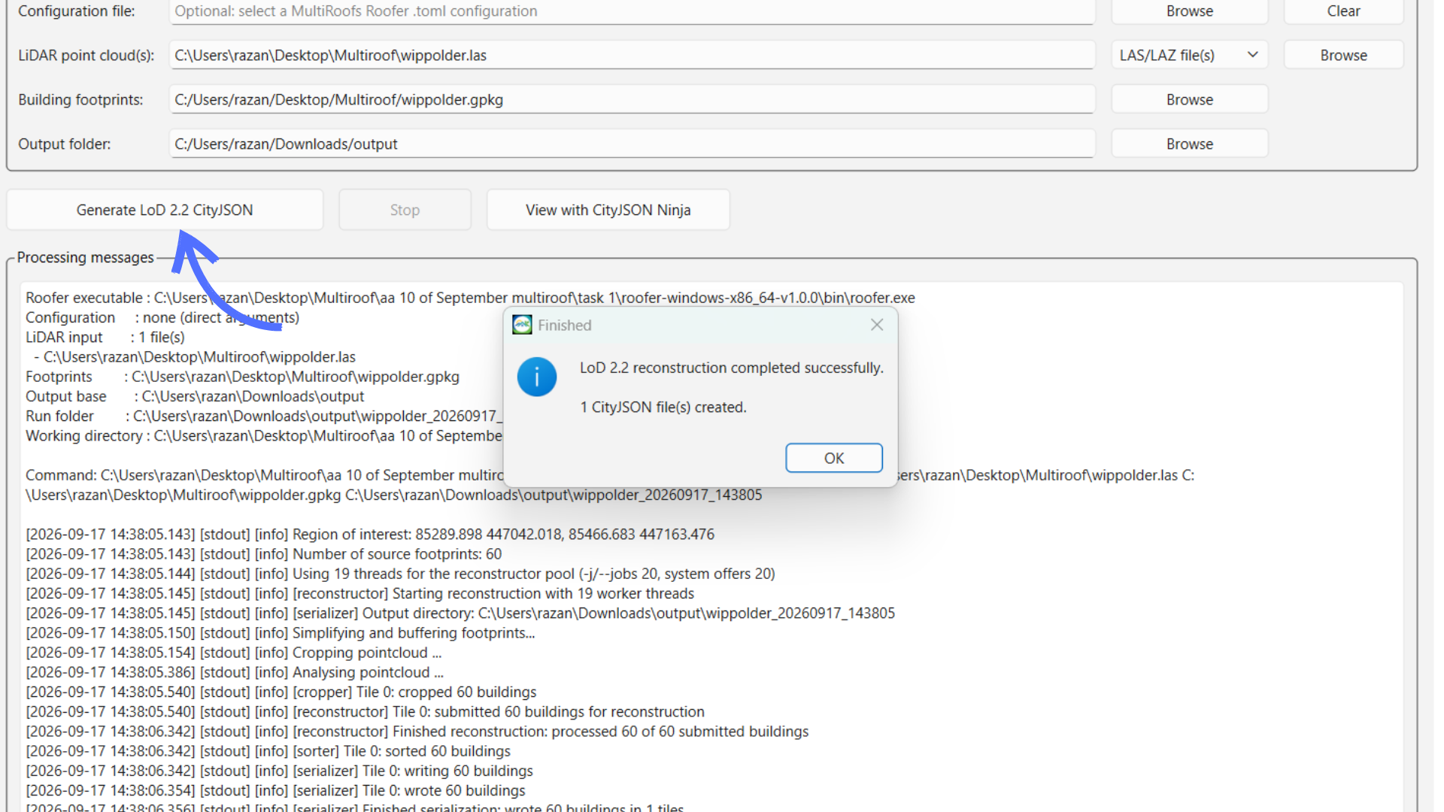
Figure 8. LoD 2.2 CityJSON generation process and successful reconstruction confirmation.

6. View the generated CityJSON model
To access and visualize the generated model, click View with CityJSON Ninja. This action opens the location of the generated CityJSON file in the system file manager, making it easy to identify the output file. At the same time, the CityJSON Ninja website opens in the default web browser. The generated CityJSON file can then be loaded into CityJSON Ninja to visualize and inspect the reconstructed 3D building model.

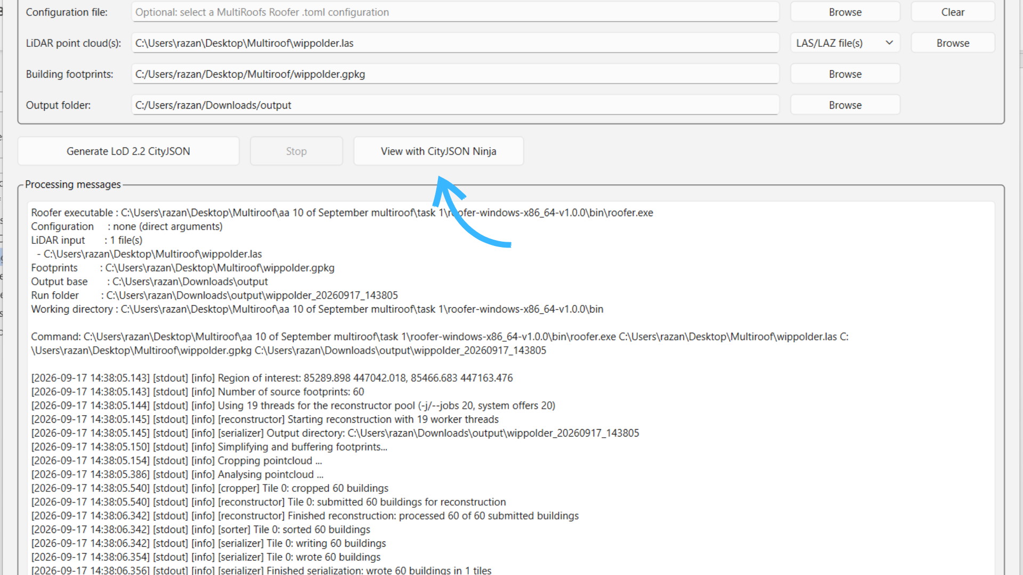

Figure 9. Accessing and visualizing the generated CityJSON model using CityJSON Ninja.

Each output is stored in a separate timestamped run folder within the selected output location, making it easier to distinguish the results of different reconstruction runs. On the CityJSON Ninja website, click Browse and select the generated file. Once the file is loaded, the reconstructed 3D building model can be viewed and explored interactively. Figure 10 and Figure 11 illustrate this process. In Figure 10, the right side shows the generated CityJSON file created from the selected LiDAR point-cloud data and .gpkg building-footprint file, while the left side shows the CityJSON Ninja website, where the generated model can be loaded and visualized.
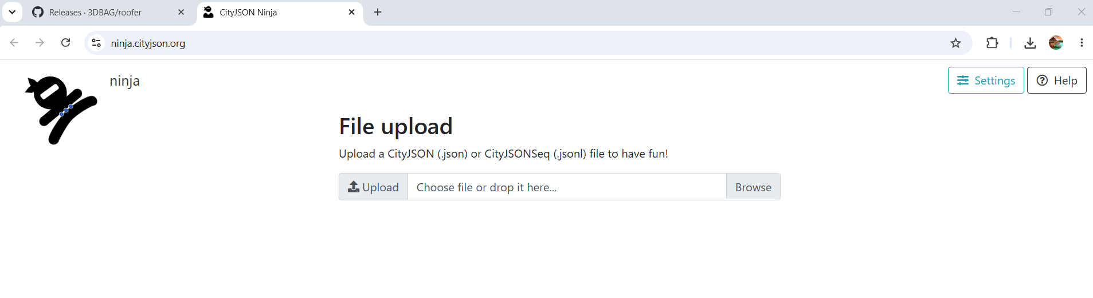  (a) CityJSON Ninja file-upload page | 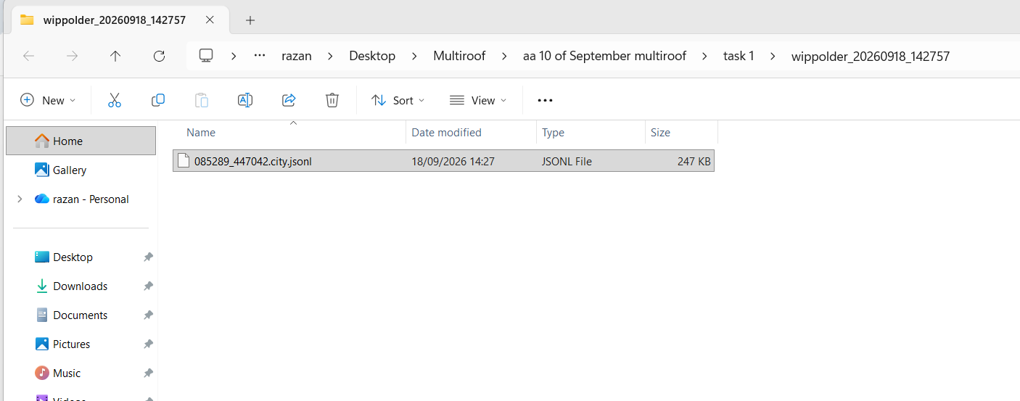  (b) Location of the generated CityJSON file

Figure 10. Accessing and visualizing the generated CityJSON model using CityJSON Ninja.

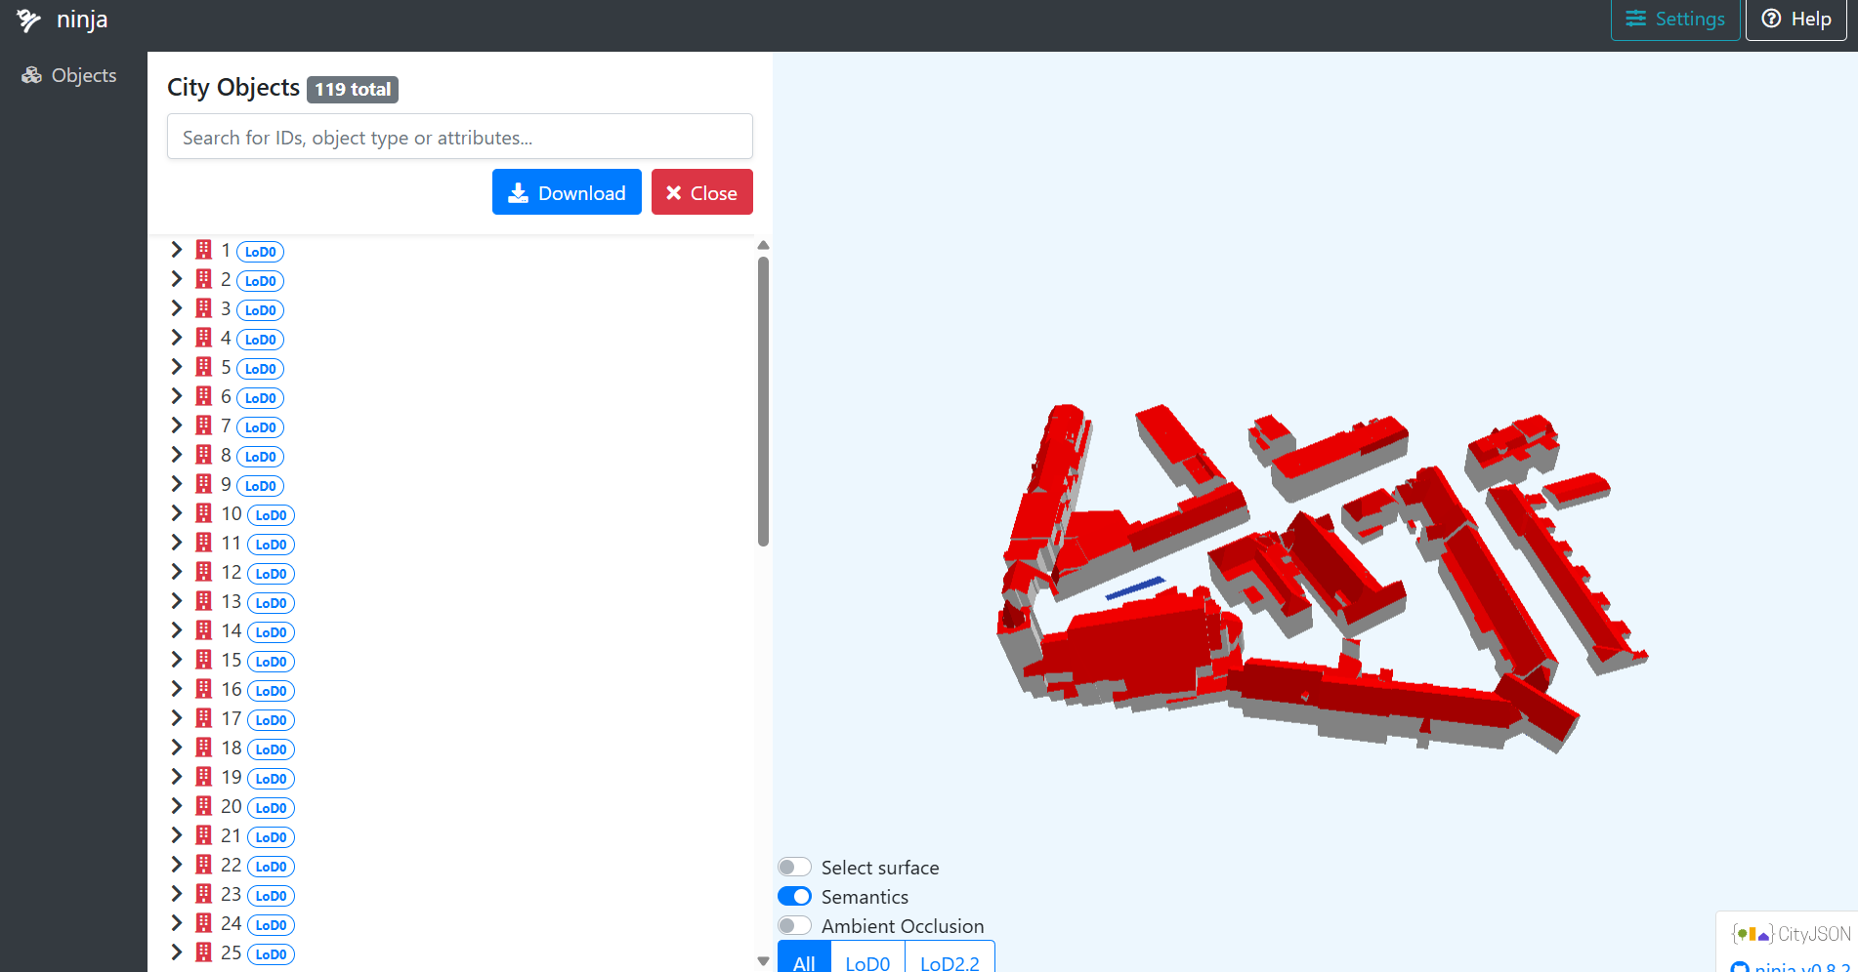 | 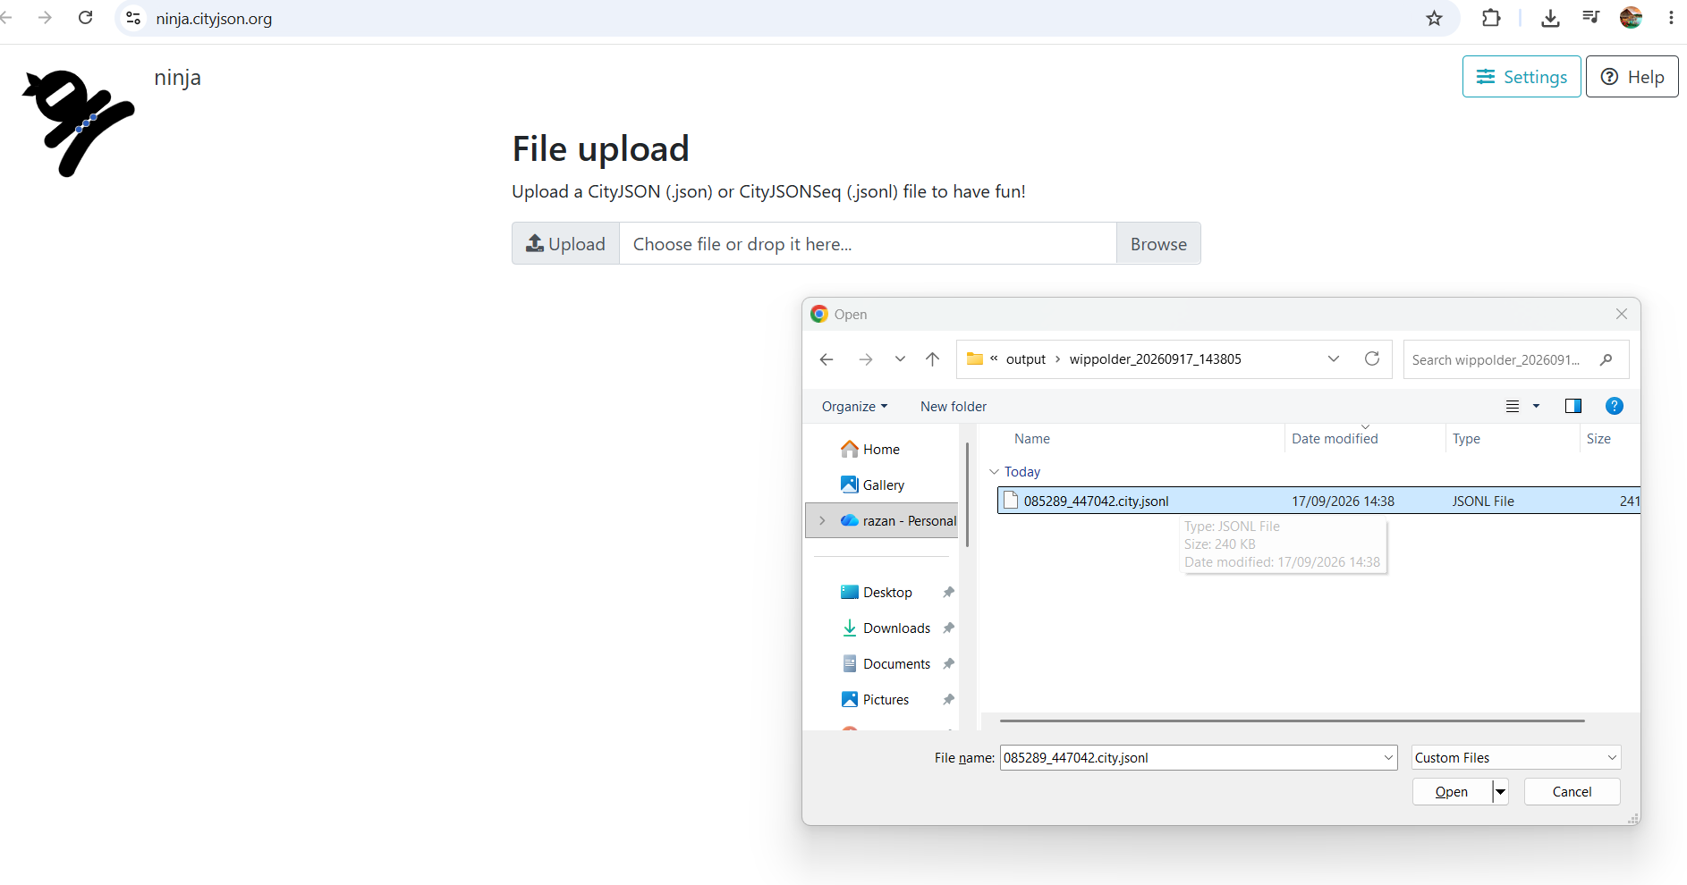

Figure 11: visualize the output file in Ninja website generated by the MultiRoof application

7. Configuration File (.toml)
The configuration file is a .toml file that contains the settings used by Roofer during the 3D building reconstruction process. Selecting a configuration file is optional. If you already have a prepared Roofer .toml configuration file, click Browse in the Configuration file section and select it. The application will use the settings defined in this file when generating the LoD 2.2 building model. If no configuration file is selected, the tool will use its default configuration settings.
As shown in Figure 12, before starting the reconstruction, first download the Roofer configuration file provided for MultiRoofs from this link Roofer config file demo for MultiRoofs.
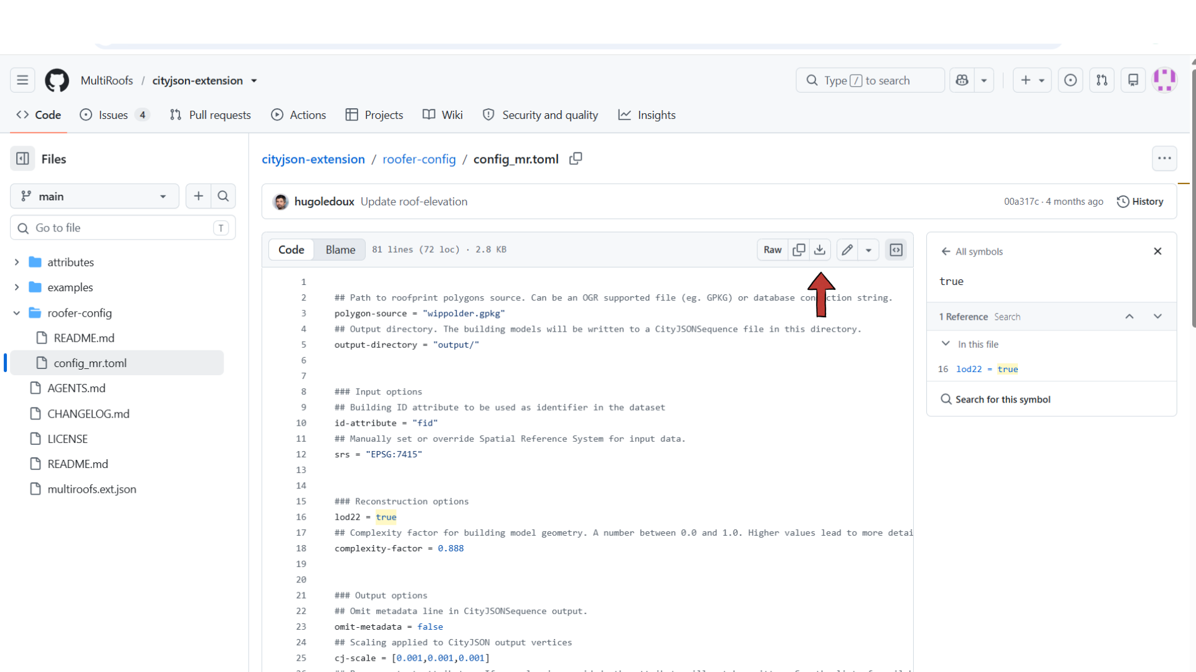

Figure 12: Download the Roofer configuration file from the link Roofer config file demo for MultiRoofs

Then open the downloaded .toml file and modify the paths to specify the locations of the building-footprint data (.gpkg) and the LiDAR point-cloud data (.las/.laz). Make sure that the specified .gpkg and .las/.laz files already exist at the locations defined in the configuration file; otherwise, Roofer will not be able to access the required input data. In addition, specify the folder where the generated output files should be stored. From Figure 13.a, the configuration file should be modified by setting polygon-source = "wippolder.gpkg" for the building footprints, output-directory = "output/" for the folder where the generated results will be stored, and, in Figure 13.b, setting the source = ["wippolder.las"] for the LiDAR point cloud. Ensure that the specified .las/.laz and .gpkg files exist at the defined locations before starting the reconstruction process.
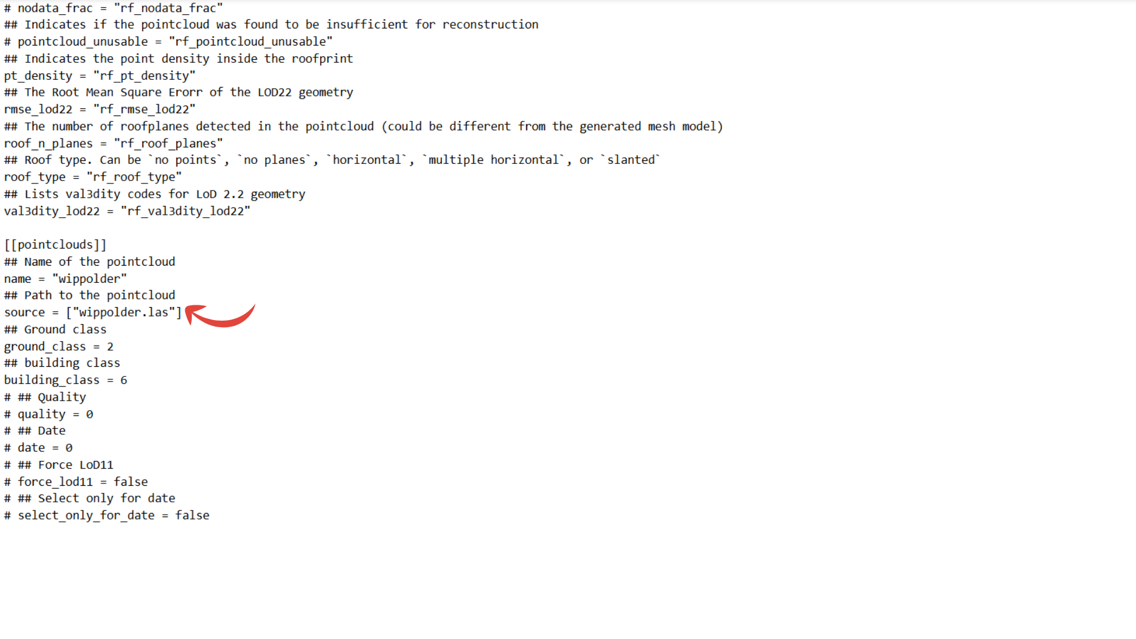  Figure 13.b Specifying the point cloud | 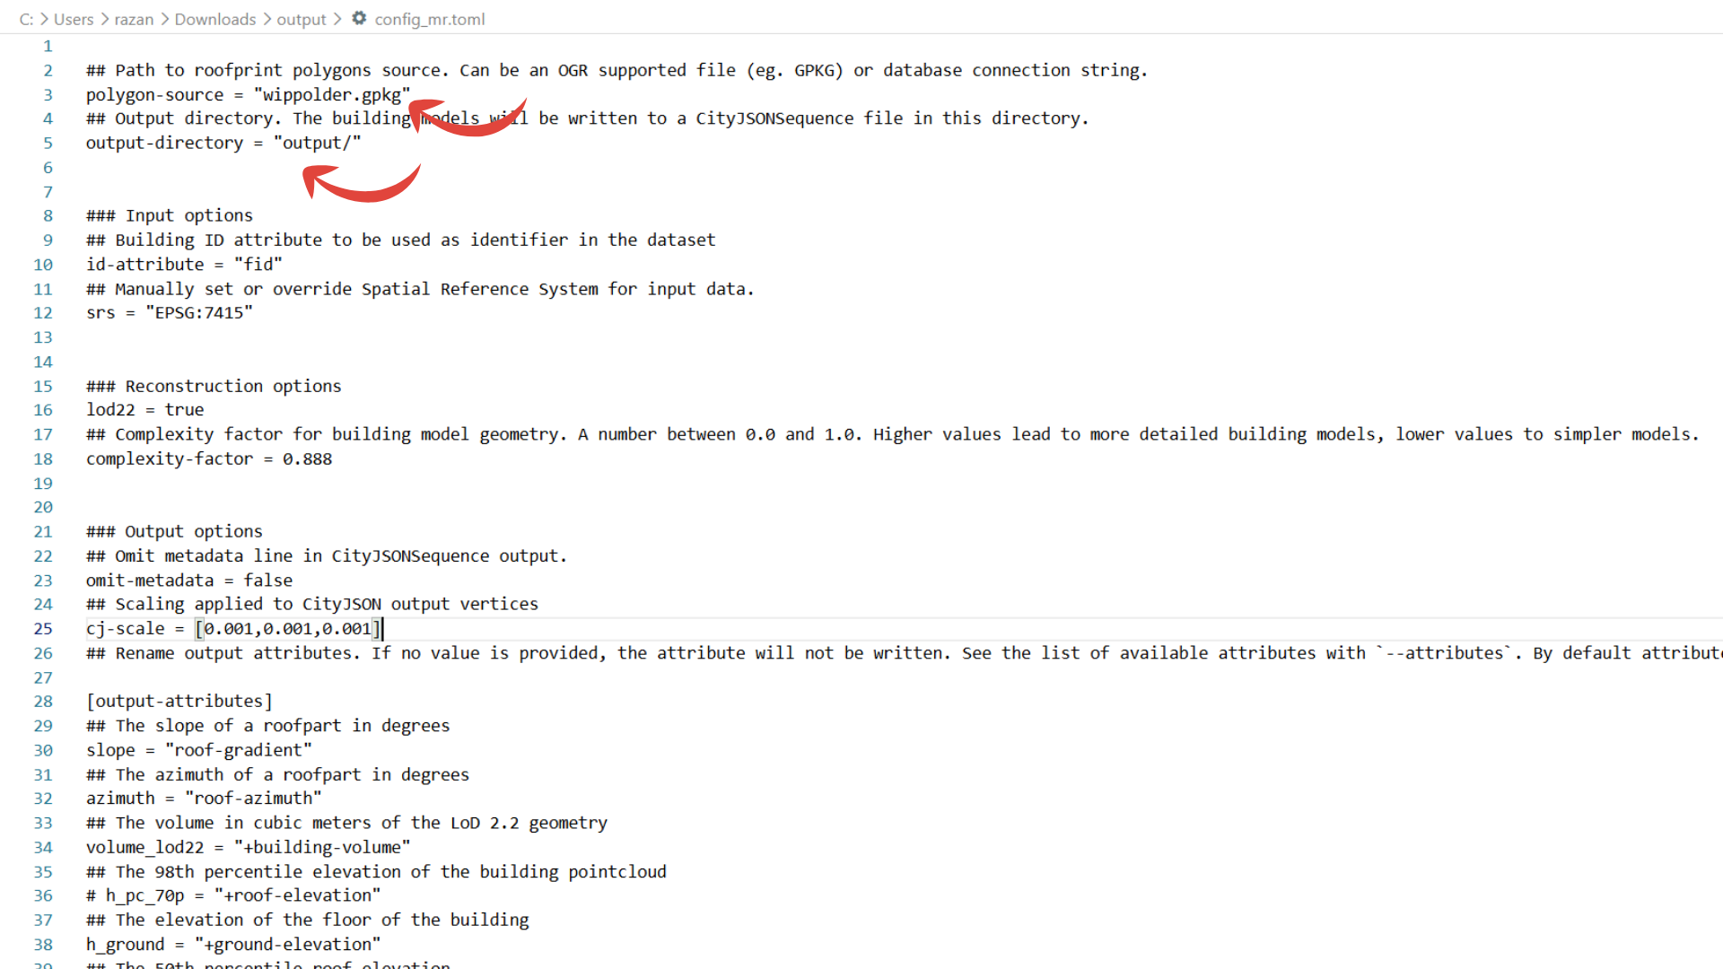  Figure 13.a Specifying the footprint and output paths in the Roofer configuration file.

After that the prepared configuration file can then be selected directly from the MultiRoofs user interface. In the Configuration file section, click Browse and select the modified .toml file. Once the configuration file has been selected, click Generate LoD 2.2 CityJSON to start the reconstruction process. When using this configuration file, the LiDAR and building-footprint locations do not need to be selected separately in the corresponding sections of the user interface, because their paths are already specified in the configuration file, as shown in Figure 14

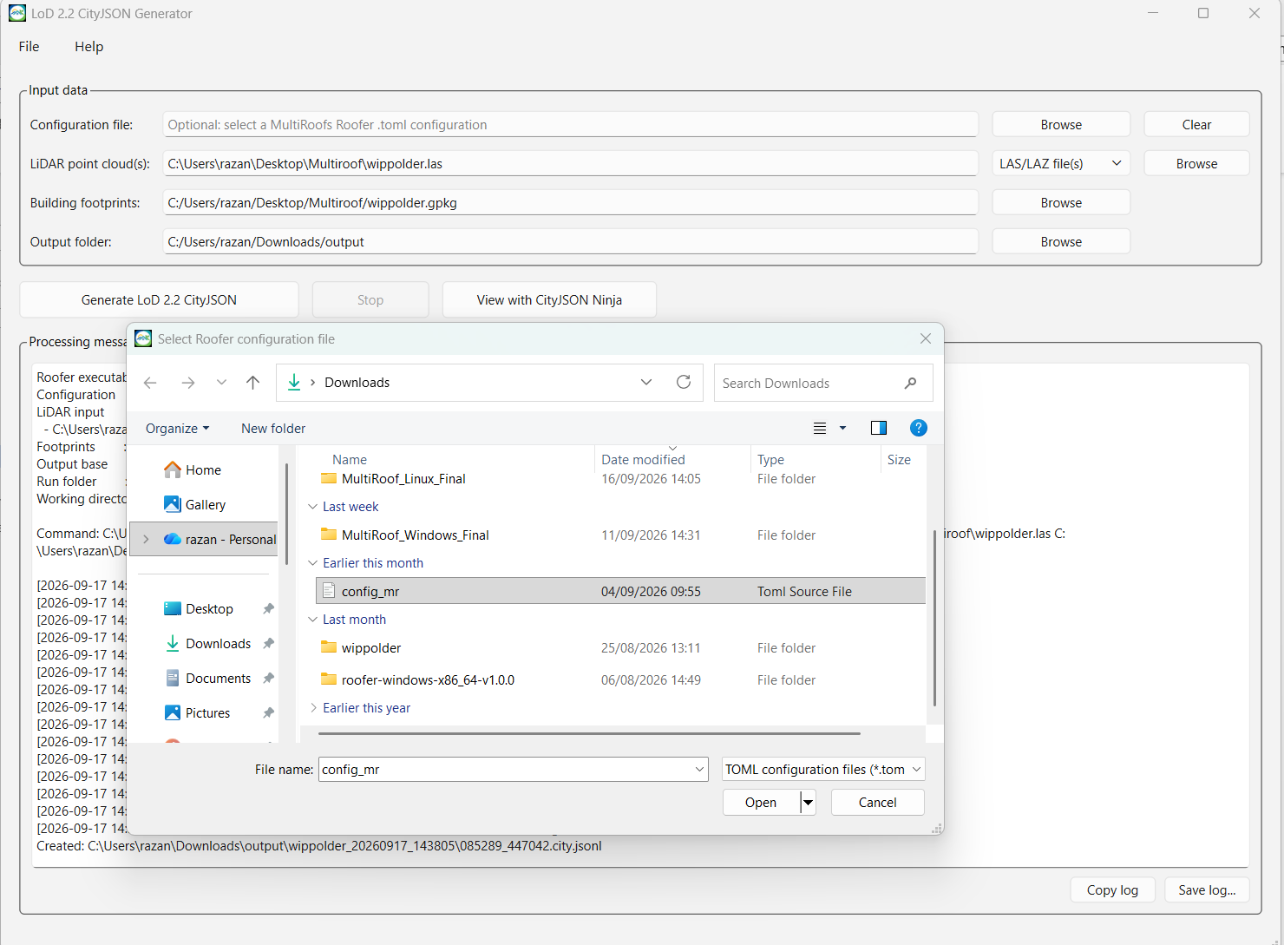

Figure 14. Selecting a Roofer configuration file and starting the LoD 2.2 CityJSON generation process.

Summary
In summary, the LoD 2.2 CityJSON Generator provides a graphical interface for generating LoD 2.2 building models using Roofer. Users can select LiDAR point-cloud data, building footprints, and an output folder, or optionally use a prepared configuration file. The interface allows users to start the reconstruction, monitor its progress through the Processing messages section, and visualize the generated 3D CityJSON model using CityJSON Ninja. The File/Settings menu is used to configure Roofer, while Help/About provides information about the tool and the MultiRoofs project as presented in Figure 15.
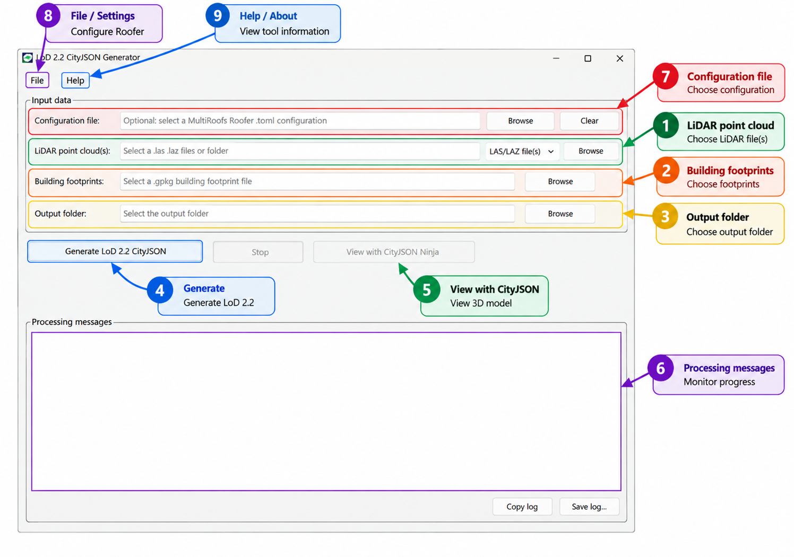Figure 15. Overview of the LoD 2.2 CityJSON Generator user interface and its main functions

